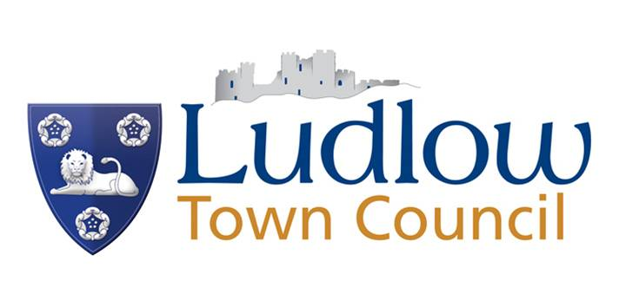

Ludlow Market
Sale of Alcohol
Permission to sell alcohol on the market must be sought from the Town Clerk

The market premises are licensed and traders who sell alcohol must comply with the law and challenge anyone who appears to be under 25 years.
The only acceptable forms of ID listed below.

Infringement is a serious matter:
Stall holders who fail to ask for ID will not be permitted to trade.
A maximum fine of £10,000 is payable by traders who break the law.
It is against the law:
- to sell alcohol to someone under 18 anywhere, and can lead to a maximum fine of £10,000 for bar staff/managers or premises being shut down.
- for an adult to buy or attempt to buy alcohol on behalf of someone under 18.
- for someone under 18 to buy alcohol, attempt to buy alcohol or to be sold alcohol.

Retailers can reserve the right to:
- refuse the sale of alcohol to an adult if they’re accompanied by a child and think the alcohol is being bought for the child.

ID for alcohol: proving your age
Acceptable forms of ID to prove you are over 18 include:
- a photo driving licence
- a passport
- a PASS card from the national Proof of Age Standards Scheme.
It’s a criminal offence to use false or borrowed ID to gain entry to licensed premises or to buy alcohol. The maximum penalty is a £5,000 fine and up to 10 years in prison.

Challenge 25
If the person asking to buy alcohol looks under 25 – you must ask for ID!
Town Clerk, Designated Premises Supervisor
August 2013

